***OOP LAB TASK – 3***

**Program– 1**

#include <iostream>

using namespace std ;

struct accountHolder {

char holdername [25] ;

char holderID [10] ;

};

struct bankAccount {

char accountnumber [25] ;

struct accountHolder hd ;

};

int main () {

bankAccount accnt ;

cout <<"Enter the Account holder name = "; cin >> accnt.hd.holdername ;

cout <<"Enter the Account holderID = "; cin >> accnt.hd.holderID ;

cout <<"Enter the Account Number = "; cin >> accnt.accountnumber ;

cout << "Holder name = " << accnt.hd.holdername << endl ;

cout << "Holder ID = " << accnt.hd.holderID << endl ;

cout << "Holder Account number = " << accnt.accountnumber ;

return 0 ;

}

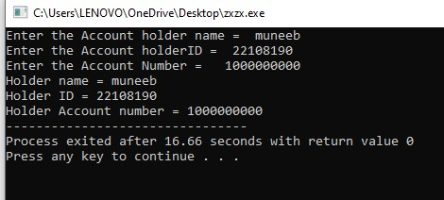

**Program : 2**

#include <iostream>

using namespace std;

struct studentInformation {

char name[50];

char ID[10];

};

struct courseDetails {

char coursename[25];

int grade;

int credits;

struct studentInformation st;

};

void transcript(courseDetails cd) {

float finalGrade ;

if (cd.grade > 80) {

finalGrade = 3.5 ;

}

else if (cd.grade > 70 && cd.grade < 80) {

finalGrade = 3.0;

}

else {

finalGrade = 2.5;

}

cout << "************ Student's Transcript ***********************" <<endl ;

cout << "Student Name: " << cd.st.name << endl;

cout << "Student ID: " << cd.st.ID << endl;

cout << "Course Name: " << cd.coursename << endl;

cout << "Your current GPA is : " << finalGrade << endl;

}

int main() {

courseDetails cd;

cout << "Enter the student name: ";

cin >> cd.st.name;

cout << "Enter the student ID: ";

cin >> cd.st.ID;

cout << "Enter the course name: ";

cin >> cd.coursename;

cout << "Enter the grade: ";

cin >> cd.grade;

cout << "Enter the credits: ";

cin >> cd.credits;

transcript(cd);

return 0;

}

